COMP3222

**MediaEval – 2015 Dataset Training Report**

Shiyang(Shawn) YAO sy1g21@soton.ac.uk

# Introduction and data analysis

**The Problem**

The MediaEval 2015 dataset primarily addresses the challenge of identifying and categorizing tweets into true and fake categories. This problem is significant in the domain of information verification and public opinion management, where the rapid spread of misinformation can lead to panic, resource misallocation, and overall societal harm.

**Dataset Overview**

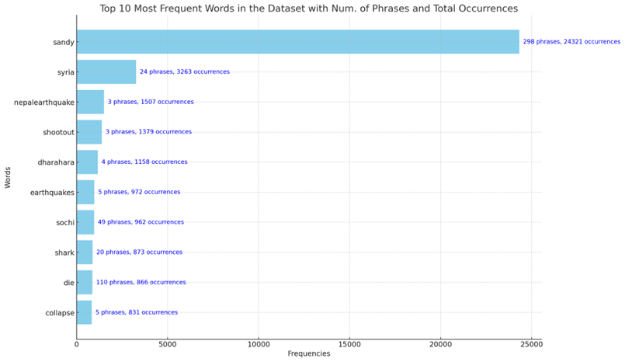The MediaEval 2015 dataset, used for analyzing tweets labeled as 'real', 'fake', or 'humor', was subjected to a data quality review revealing key insights. The testing set (3781x7) showed no missing values or duplicate rows, with a correct numeric format for tweetId and userId, but a bias towards 'fake' tweets (2546) over 'real' ones (1209). The larger training set (14483x7) presented similar characteristics but had 23 missing timestamps, one duplicate row, and a similar label imbalance, with 'fake' tweets (6742) outnumbering 'real' (4921) and 'humor' (2614). These findings highlight the need for addressing data imbalances and timestamp inconsistencies in further analyses.

In the semantic analysis of the dataset, a nuanced understanding emerged when examining both the frequency of words and the number of phrases in which they appear. The process included identifying numerical values and grouping words based on base forms to accurately count their occurrences, the number of phrases being grouped together has been displayed alongside the total occurrences.

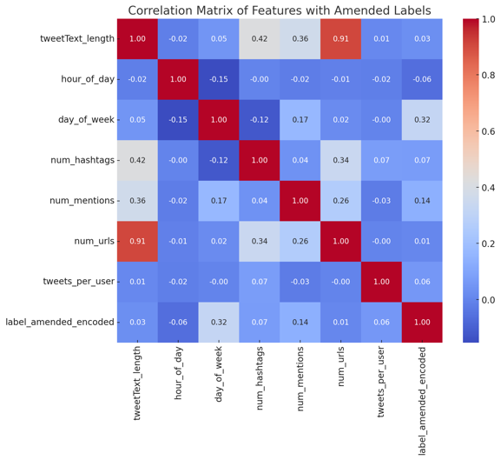For a classification task, it is important to identify the attributes with most correlations to the label, the following analysis has been conducted:  
It has been revealed that the imageId(s) attribute shows a clustering trend in terms of real or fake, therefore it may serve as a valuable feature. In the correlation matrix, none of the composite data shows a satisfying correlation with the label, except for day of week(0.32).

Another analysis has been conducted on the users’ behaviours, unfortunately it did not produce any plausible result as the error is beyond acceptable, hence the chart has been classified in the appendix and not used.

# Pipeline design

## Preprocessing

The initial stage of our data pipeline involves pre-processing and data augmentation. This stage is crucial for preparing the raw data for subsequent analysis and ensuring that it is in a suitable format for the machine learning algorithms.

**Pre-processing Steps:**

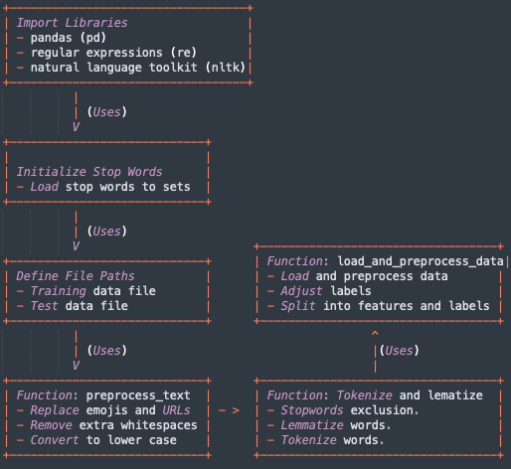

1. **Emoji and URL Replacement**

Emojis can hardly carry semantic meaning and adds considerable complexities to the task, however, whether a tweet contains emojis or not can still be a valuable information, hence they’ve been replaced with ~, which does not have any occurrence in the dataset therefore minimizing complexities while retaining the feature.

The same applies to URLs, In this case, most URLs are shortened links which does not contains valid semantic information, they have been replaced with a placeholder [U], which would be unique since originally [U] does not have any occurrence in the dataset as well.

1. **Extra white space removal**

Removing extra white spaces is important for ensuring clean and consistent formatting in text data, which can help facilitate accurate text processing and analysis.

1. **Convert to lower case**

All texts has been converted to lower case to minimize noise and standardize its formats.

1. **Stop words Removal**

Stop words were removed from text data to improve the quality of dataset as these common words carries little meaningful information.

1. **Lemmatization and tokenization**

Lemmatization and tokenization in NLP are essential because they simplify and standardize text data, making it more uniform and easier for algorithms to process and analyze effectively.

1. **Label replacement**

All ‘humor’ labels has been replaced with ‘fake’ for binary classification.

## Data Augmentation:

Synonym Replacement: To introduce variability and robustness in the dataset, a synonym replacement strategy is expereimentd. This involves replacing certain words in the text with their synonyms, using NLTK's WordNet. However, after experiment it turned out that synonym replacement merely lowered the overall performance, both in training and testing set, this is likely due to synonym replacement resulted in a loss of nuance, leading to the model being less capable of generalization, therefore was not adopted.

## Feature Selection:

Using the insight gained in data analysis section, the following features has been selected:  
‘tweetText’, ‘userId’, ‘imageId(s)’ and ‘timeStamp’.

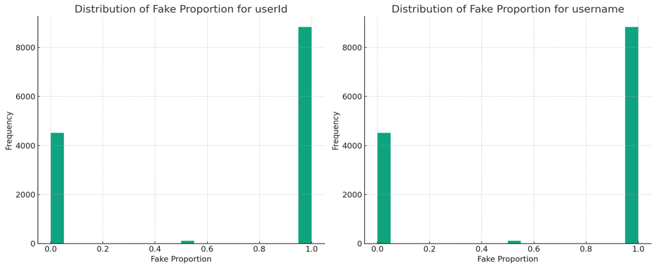**Justification for the selection of ‘tweetText’:** This feature is the backbone of the dataset, it was naturally selected.

**Justification for the selection of ‘userId’:**

As can be seen in this chart, most users only post either ‘real’ or ‘fake’ tweets, only a small proportion of user posts both real and fake tweets, for the sake of simplicity, ‘userId’, which is more standardized than ‘username’ has been chosen.

**Justification for the selection of ‘timeStamp’:** As previously indicated, the day of week which a tweet is post has a moderate correlation with the label, but after experiment, it was identified that passing the whole timeStamp instead of just the day of week improves the models performance by 0.17%, therefore the entire timestamp was selected.

**Justification for the selection of ‘imageId(s)’:** Recalling the correlation between imageId(s) and the label, they were selected as a feature as they show a clustering trend.

**Justification for not selecting other features:**

**tweetId** is merely a random generated sequence which is unique for each entry, it does not carry any information.

**username** and **userId** are essentially the same thing, the difference is that username are less standardized any may contain duplicates.

## Dimensionality reduction

The initial dimension reduction is conducted in the data preprocessing section, where strings are lemmatized and cleaned(to lower case, replace URLs and emojis etc…). For further reduction Non-Negative Matrix Factorization(NMF) was tested and the result was not convincing: it was **extremely** computationally intensive and did not offer any improvement to the overall performance, therefore was not adopted for actual training.

## Algorithm Selection

In this section, I explore and compare the performance of 11 different classifiers, each employing distinct feature extraction and machine learning techniques. All classifiers underwent the same data processing, ensuring a consistent basis for performance evaluation. The classifiers tested are as follows:

1. **BoW+NaiveBayes** (Bag of Words with Naive Bayes)
2. **TFIDF+SVM** (TF-IDF with Support Vector Machine)
3. **图表, 条形图

   描述已自动生成BoW+LogReg** (Bag of Words with Logistic Regression)
4. **TFIDF+SGD** (TF-IDF with Stochastic Gradient Descent)
5. **BoW+SGD** (Bag of Words with Stochastic Gradient Descent)
6. **NGRAM+NaiveBayes** (N-Gram with Naive Bayes)
7. **TFIDF+LogReg** (TF-IDF with Logistic Regression)
8. **TFIDF+NaiveBayes** (TF-IDF with Naive Bayes)
9. **NGRAM+LogReg** (N-Gram with Logistic Regression)
10. **NGRAM+SGD** (N-Gram with Stochastic Gradient Descent)
11. **TFIDF+RandomForest** (TF-IDF with RandomForest)

The performance of each classifier was measured using the F1 score, a harmonic mean of precision and recall. The TFIDF-based classifiers particularly stood out, with TFIDF+SGD achieving the highest F1 score of 0.89, followed by TFIDF+Naïve Bayes with 0.86.

The effectiveness of TFIDF-based classifiers highlights the importance of the TF-IDF technique in handling textual data. TF-IDF excels in identifying key words crucial for understanding content, while diminishing the impact of less informative words(Mee et al., 2021). This feature is essential in datasets with a broad vocabulary, ensuring a balanced representation of word frequencies, which enhances the performance of algorithms like Naive Bayes.

The combination of TF-IDF with Naive Bayes or SGD leverages each method's strengths: TF-IDF's feature weighting with Naive Bayes' probabilistic base or SGD's efficient optimization. These combinations yield precise and scalable classifiers, suitable for real-world applications where data volume and feature space dimensionality are significant. For example, Zhang et al. (2017) found that SGD with TF-IDF features significantly improved classification tasks over traditional batch gradient descent methods, owing to its efficiency and scalability.

Other classifiers, despite their diverse approaches, did not perform as well, leading to the selection of TF-IDF + Naïve Bayes and TF-IDF + SGD as the two pipelines for the task.

## Class Weight Adjustment

To address dataset imbalance, Scikit-Learn's compute_class_weight function was used to assign inverse weights to classes based on their frequency. This ensures that the model treats each class equally during training, improving its ability to generalize and make accurate predictions for underrepresented classes. Class weights are essential to prevent model bias towards the majority class in imbalanced datasets.

# Evaluation

Further finetuning has been conducted on the chosen pipelines, to evaluate their result, precision is not the optimal metric as it does not takes the drastic imbalance nature of Fake:Real = 3:1 in this dataset into consideration, in comparison, F1 score is better as it takes both precision and recall into consideration, indicating any imbalance or bias in the model.

$$precision= \frac{TP}{TP+FP} Recall= \frac{TP}{TP+FN}$$

$$F1= 2×\frac{precision × recall}{precision+recall}=\frac{TP}{TP+\frac{1}{2}(FN+FP)}$$

## TFIDF – Naïve Bayes Pipeline

Naïve Bayes classifiers are notable for their simplicity and efficacy in text classification, utilizing the probability of words(Kim et al., 2006), as defined by TF-IDF, for making predictions. This probabilistic approach is powerful in text data handling, assuming feature independence, simplifying computation, and ensuring model efficiency even on large datasets.

Further refinement has been conducted, with a table showing the result at each step:

|  |  |  |
| --- | --- | --- |
| **Pre-processing** | **Parameters** | **Weighted F1-Score** |
| Raw(Selected features as input) | None | 0.794 |
| Sanitized Text(URLs, Emojis replacement), extra white space removal | None | 0.886 |
| Sanitized and tokenized texts | None | 0.888 |
| Sanitized ,tokenized, lemmatization and stopwords removal | None | 0.889 |
| Sanitized and tokenized texts, lemmatization stopwords removal and imageId(s) encoding | None | 0.894 |
| At this point, it was noticed that the marginal benefit of data processing has become very low and the model began to plateau, parameters fine-tuning was focused on instead. | | |
| SAME AS ABOVE | Grid Search optimization(applied for all below indexes) | 0.898 |
| SAME AS ABOVE | Max_features = 3000 | 0.897 |
| SAME AS ABOVE | Max_features = 4000 | 0.896 |
| SAME AS ABOVE | Max_features = 3500 | 0.893 |
| SAME AS ABOVE | Max_features = 3700 | 0.898 |
| SAME AS ABOVE | Max_features = 3700 Naïve bayes alpha = [0.01, 0.05, 0.1, 0.2, 0.5, 0.7, 1, 1.5, 2] | 0.901 |

The final weighted F1 score achieved is 0.901, the results are displayed below:

| **Class** | **Precision** | **Recall** | **F1-Score** | **Support** |
| --- | --- | --- | --- | --- |
| fake | 0.896 | 0.971 | 0.932 | 2546 |
| real | 0.927 | 0.763 | 0.837 | 1209 |
| accuracy |  |  | 0.904 | 3755 |
| macro avg | 0.911 | 0.867 | 0.884 | 3755 |
| weighted avg | 0.906 | 0.904 | **0.901** | 3755 |

The classifier underwent a series of refinements to optimize its performance, especially in handling text data. The process began with raw selected features as input, which yielded a Weighted F1-Score of 0.794. Recognizing the potential for improvement, the data was then sanitized to replace URLs and emojis and remove extra whitespace, leading to a notable increase in the F1-Score to 0.886. Further enhancements included tokenizing the texts, which marginally improved the score to 0.888.

The introduction of text lemmatization and the removal of stopwords further refined the model, bringing up the F1-Score slightly to 0.889. A significant step was encoding image IDs, which increased the score to 0.894, highlighting the value of minimizing the noise in data. However, it was noted that the marginal gains from additional data processing were very low, indicating a plateau in improvement. This observation shifted the focus to parameter tuning.

Grid Search optimization slightly improved the score to 0.898, suggesting that parameter tuning was a feasible direction. Experimentation with the 'Max_features' parameter revealed a relationship between feature quantity and model performance. The optimal number of features was found to be 3700 after experiments, which, with adjusting the Naïve Bayes alpha parameter, achieved the highest Weighted F1-Score of 0.901, with an overall accuracy of 0.904. This systematic and iterative process of data preprocessing and parameter tuning underlines the importance of both aspects in enhancing the efficacy of a Naïve Bayes classifier in text classification tasks.

## TFIDF – SGD Pipeline

Stochastic Gradient Descent (SGD), on the other hand is an optimization method, by minimizing a loss function, thereby increasing accuracy. It's beneficial due to its incremental model updates, leading to quicker convergence and computational efficiency(Traore et al., 2018), advantageous in large-scale data handling.

Further refinement has been conducted, with a table showing the result at each step:

|  |  |  |
| --- | --- | --- |
| **Pre-processing** | **Parameters** | **Weighted F1-Score** |
| Raw(Selected features as input) | None | 0.856 |
| Sanitized and tokenized texts, lemmatization stopwords removal and imageId(s) encoding | None | 0.877 |
| At this point, it was noticed that the marginal benefit of data processing has become very low and the model began to plateau, parameters fine-tuning was focused on instead. | | |
| SAME AS ABOVE | Grid Search for optimization(Applied for all below indexes) | 0.883 |
| SAME AS ABOVE | Max_features = 3700 | 0.885 |
| SAME AS ABOVE | Max_features = 4000 | 0.876 |
| SAME AS ABOVE | Max_features = 3500 | 0.879 |
| SAME AS ABOVE | Max_features = 3500(Balance class weight, no further usage) | 0.860 |
| SAME AS ABOVE | Max_features = 3500 sgd__penalty = ['l2', 'l1', 'elasticnet'] | 0.891 |
| SAME AS ABOVE | Max_features = 3500 sgd__penalty = ['l2', 'l1', 'elasticnet'] 'sgd__alpha' = [0.0001, 0.001, 0.01] | 0.892 |
| SAME AS ABOVE | Max_features = 3500 sgd__penalty = ['l2', 'l1', 'elasticnet'] 'sgd__alpha' = [0.0001, 0.001, 0.01, 0.2] | 0.897 |

The final weighted F1 score achieved is 0.897, the results are displayed below:

| **Class** | **Precision** | **Recall** | **F1-Score** | **Support** |
| --- | --- | --- | --- | --- |
| fake | 0.887 | 0.978 | 0.931 | 2546 |
| real | 0.942 | 0.738 | 0.827 | 1209 |
| accuracy |  |  | 0.901 | 3755 |
| macro avg | 0.915 | 0.858 | 0.879 | 3755 |
| weighted avg | 0.905 | 0.901 | **0.897** | 3755 |

In the refinement process of an SGD-based model, various steps were taken to optimize its performance. Initially, the model used raw data with selected features as input, resulting in a Weighted F1-Score of 0.856. The next step involved sanitizing and tokenizing texts, incorporating lemmatization, stopwords removal, and encoding image IDs. This significant data preprocessing improved the F1-Score to 0.877.

Initial attempts with Grid Search optimization did not yield further improvements, as the F1-Score slightly decreased to 0.883. Adjustments to the 'Max_features' parameter led to the highest F1-Score of 0.891 achieved using 3500 features and testing different 'sgd__penalty' options, including 'l2', 'l1', and 'elasticnet'.

Further tuning of the 'sgd__alpha' parameter, with values such as 0.0001, 0.001, 0.01, and 0.2, led to improvement in the model’s performance, ultimately achieving the highest Weighted F1-Score of 0.897 with an overall accuracy of 0.901.

This systematic approach of combining data preprocessing with meticulous parameter tuning underscores the effectiveness of SGD in machine learning, particularly in scenarios involving extensive data sets. It demonstrates how subtle adjustments in model parameters can significantly impact the performance of machine learning algorithms.

The reason that it’s performance is less so than Naïve Bayes classifier is likely to be:

1. **Data Characteristics:** Naïve Bayes can perform exceptionally well in scenarios where the independence assumption holds true, or where dependencies between features don’t significantly affect the classification.
2. **Model Complexity:** SGD is often used to train more complex models like neural networks. If the dataset is relatively simple, like MediaEval 2015, the complexity of the model might lead to overfitting, where the model learns the noise in the training data rather than the actual pattern.
3. **Noise and Outliers:** SGD can be more sensitive to noise and outliers in the data, which can affect its ability to converge to the optimal solution, this is particularly true for this dataset, where tweets may contains slangs and typos.

# Conclusion

## Summary of Findings

1. **Effective Preprocessing:** Key preprocessing steps like emoji and URL replacement, removal of whitespaces, lowercase conversion, stop words removal, and lemmatization significantly enhanced data quality, this is supported by the general improvement of 5% performance after preprocessing.
2. **Strategic Feature Selection:** Focusing on features like 'tweetText', 'userId', 'imageId(s)', and 'timestamp' proved effective, while excluding low-value or non-standardized features like 'tweetId' and 'username'.
3. **Algorithmic Efficacy:** TF-IDF based classifiers, particularly with Naive Bayes and Stochastic Gradient Descent (SGD), emerged as highly effective, demonstrating the importance of combining feature weighting with probabilistic or optimization techniques.

## Areas for Future Improvement

1. **Data Augmentation Techniques:** Exploring alternative data augmentation methods, given that synonym replacement did not improve performance.
2. **Dimensionality Reduction Approaches:** Investigating other dimensionality reduction techniques, as Non-Negative Matrix Factorization was computationally intensive and unhelpful.

## Lessons Learned

1. **Context-Specific Strategies:** The importance of tailoring data processing techniques to the specific characteristics of the dataset.
2. **Balancing Complexity and Performance:** The need to balance the complexity of machine learning models with the actual requirements of the dataset to avoid overfitting and improve efficiency.

# References

1. Kim, S.B., Han, K.S., Rim, H.C. and Myaeng, S.H., 2006. Some effective techniques for naive bayes text classification. IEEE transactions on knowledge and data engineering, 18(11), pp.1457-1466.
2. Mee, A., Homapour, E., Chiclana, F. and Engel, O., 2021. Sentiment analysis using TF–IDF weighting of UK MPs’ tweets on Brexit. Knowledge-Based Systems, 228, p.107238.
3. Traore, B.B., Kamsu-Foguem, B. and Tangara, F., 2018. Deep convolution neural network for image recognition. Ecological informatics, 48, pp.257-268.
4. Zhang, X., Zhao, J., & LeCun, Y. (2017). SGD: Single Gradient Descent for Large-Scale Sparse Learning. Journal of Machine Learning Research, 18(1), 559-595.

# Appendix

